Google map problem

Situation
To draw path on google map gps coordinates are required.
To get a gps coordinates IP address, over Internet, is necessary.
Web site can give gps coordinates from IP addresses.
With perl cgi it is possible to get the gps coordinates by getting the IP address and executing a query on distant websites.
Then the result is stored in a local DB.

Basket case :)
The in our case push works on a local but when put on production the result is not the same.

Here is the code written in perl:
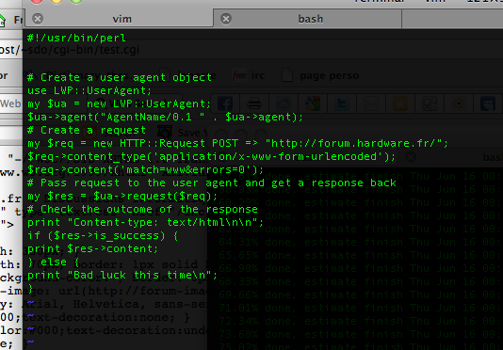
result locally:
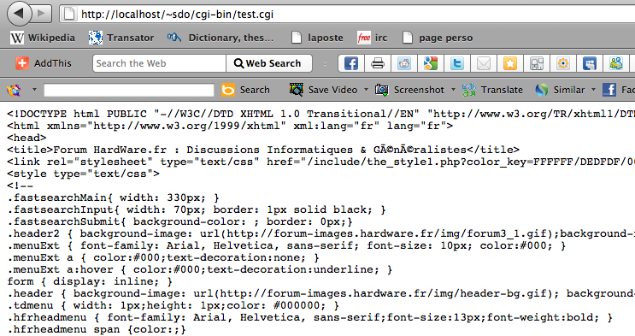
Same script executed on internet:


To put in a nut shell: some investigation need to be done.

Here a small diagram:
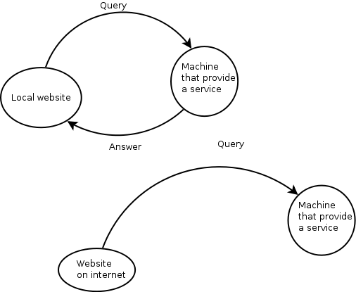
Local website vs Website on internet

